Limelight
PowerSchool – Limelight Edition
Reporting Enhancements

Tree View Enhancements
The tree views for the Item Assessment, Student Proficiency, and Standards Assessment reports for assignment data have been expanded to include District and Section groupings. This will enable better comparative analysis of student results as well as classroom performance against others in the school and the district.

District Grouping
A new row called District has been added to the tree view for all three reports.

- The District row appears for all assignments.
  - If the test was created and assigned or published by a district administrator, the District row will be populated with data.
  - If the test was created and assigned by a school administrator or teacher, the District row will display N/A, since there is no District-level data available for comparison.
- The District is not a selectable group -- the tree view always defaults to District as the highest grouping.

Item Assessment
The District row in the Item Assessment tree view shows the total points earned for each item on the test across all students in the district who completed the assignment.

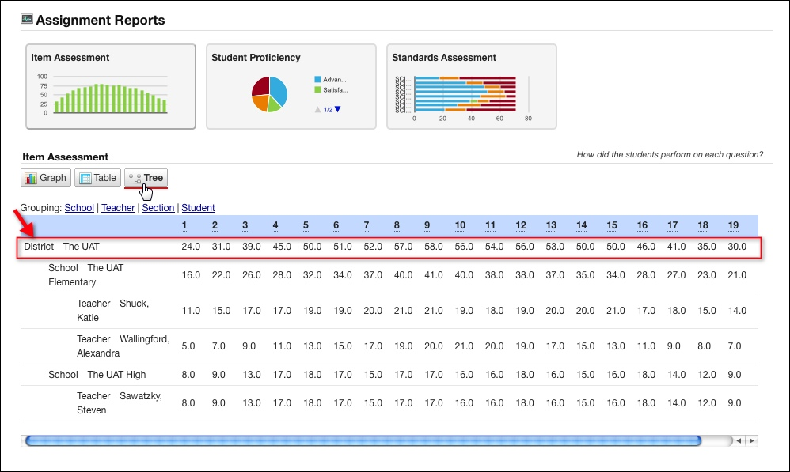
Figure 1: Item Assignment Tree with District Roll-up

Student Proficiency
The District row in the Student Proficiency tree view shows the average percent score and average points earned of available points on the test. The District average is calculated based on the scores received by all the students in the district who completed the assignment.

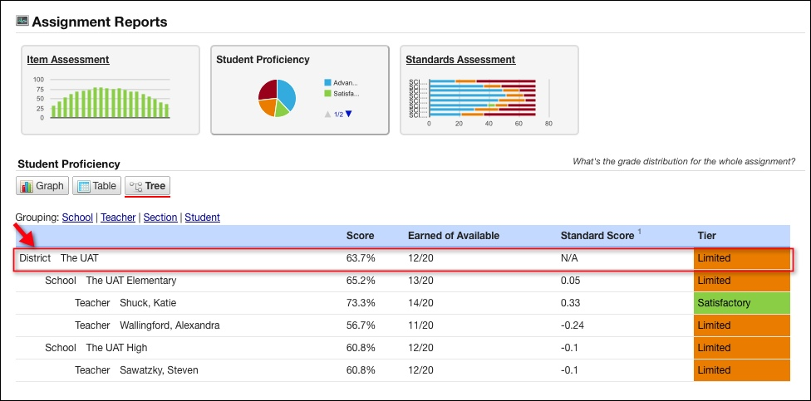
Figure 2: Student Proficiency Tree with District Roll-up

*Note that the Standard Score for the District will always be N/A. The standard score is how much the school, teacher, and student scores deviate from the District average. The District does not have a deviation because it is the point of reference.

Standards Assessment
The District row in the Standards Assessment tree view shows the average percent score for each standard assessed on the assigned test. The District average is calculated based on the scores received by all the students in the district who completed the assignment.

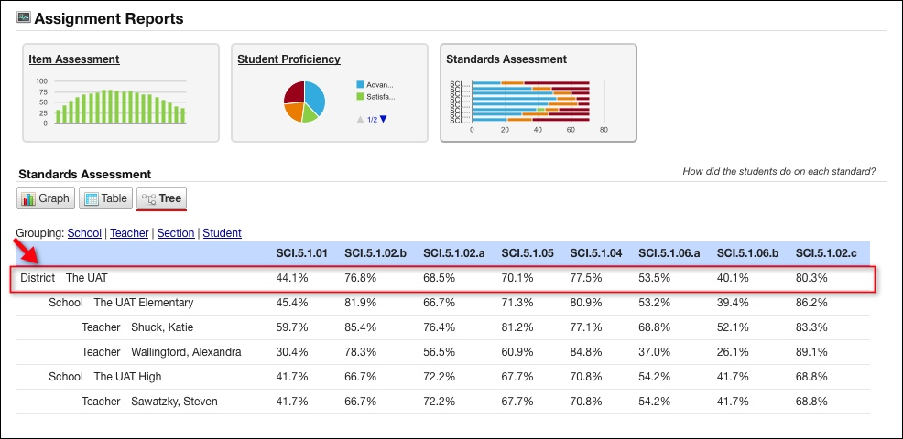
Figure 3: Standards Assessment Tree with District Roll-up

Section Grouping
A new grouping called Section has been added to the tree view for all three reports.

- The Section grouping is selectable by all users.
- The Section grouping appears below the Teacher grouping, so that each section in the assignment is listed in the tree view below the teacher to whom the section belongs.
- The Student grouping will include the students in each section, so that each student in the assignment is listed in the tree view below the section that the student belongs in.

Item Assessment
Each Section row in the Item Assessment tree view shows the total points earned for each item on the test across all students in that section who completed the assignment.

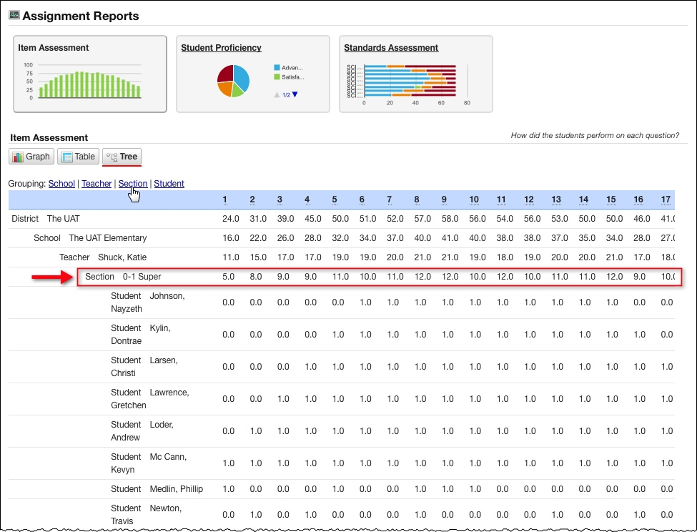
Figure 4: Item Assessment Tree with Section

Student Proficiency
A Section row in the Student Proficiency tree view shows the average percent score, average points earned of available points on the test, and the average standard score. For each section, the averages are calculated based on the scores received by all the students in that section who completed the assignment.
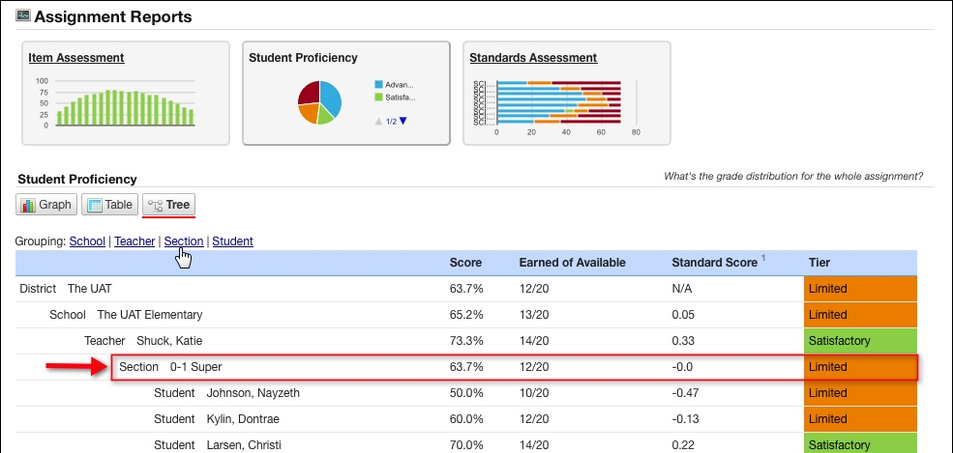
Figure 5: Student Proficiency Tree with Section

Standards Assessment
A Section row in the Standards Assessment tree view shows the average percent score for each standard assessed on the test. For each section, the average score is calculated based on the scores received by all the students in that section who completed the assignment.

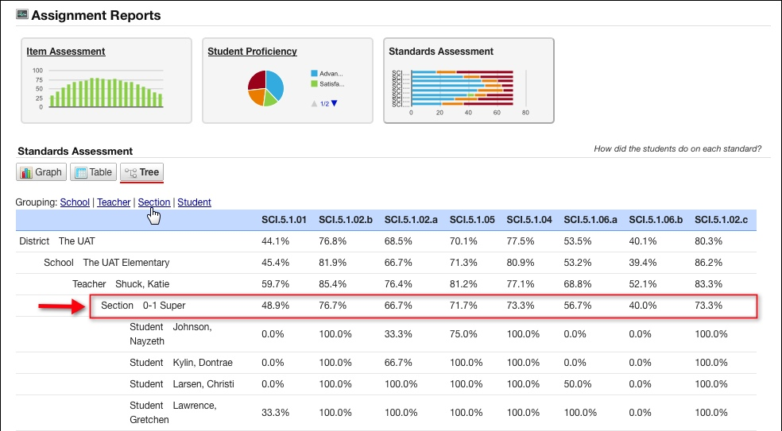
Figure 6: Standards Assessment Tree with Section

